The Lightweight IBM Cloud Garage Method for Data Science

Architectural Decisions Document Template

# Architectural Components Overview

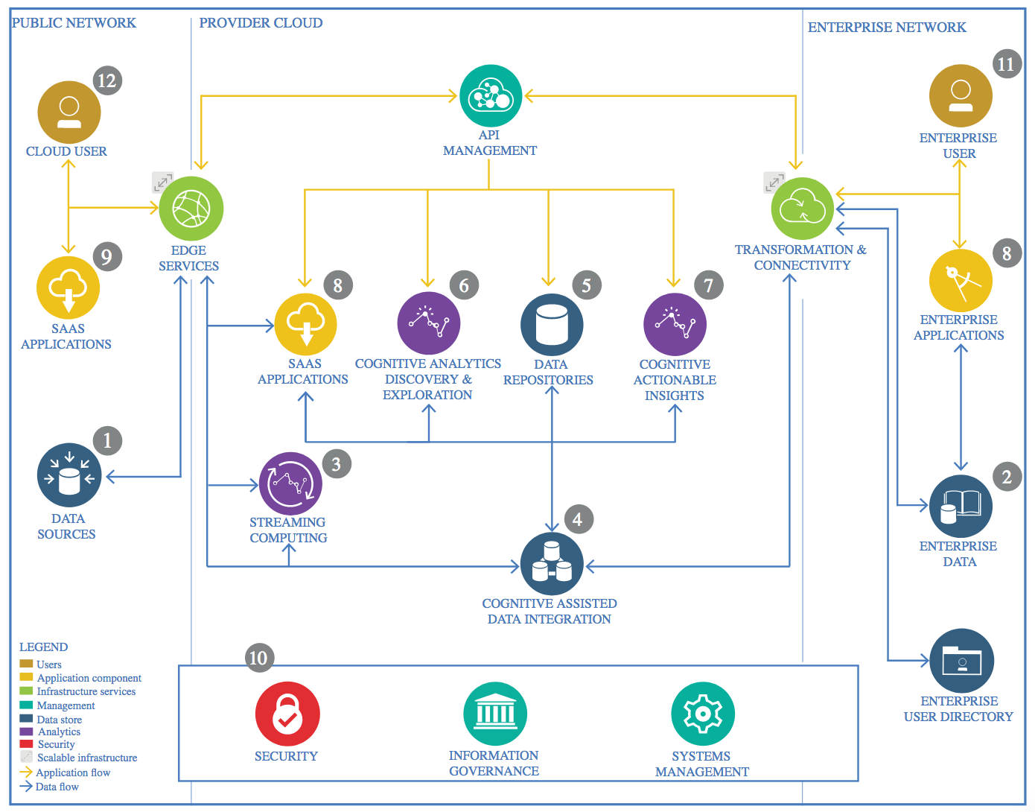

IBM Data and Analytics Reference Architecture. Source: IBM Corporation

## Data Source

**Mexican government – Ministry of Health**

<https://datos.gob.mx/busca/dataset/informacion-referente-a-casos-covid-19-en-mexico>

### Technology Choice

The database used has a daily update and needs to download continuously. For this case, the information is collected using “wget” command in Python. This command helps to retrieve information directly from the internet and stored into specific location.

As a matter of fact, the CoVid information is updated daily and for that reason it is necessary to create a specific process to collect the information and update continuously.

### Justification

Please justify your technology choices here.

## Enterprise Data

### Technology Choice

Please describe what technology you have defined here. Please justify below, why. In case this component is not needed justify below.

### Justification

Please justify your technology choices here.

## Streaming analytics

### Technology Choice

Please describe what technology you have defined here. Please justify below, why. In case this component is not needed justify below.

### Justification

Please justify your technology choices here.

## Data Integration

### Technology Choice

Please describe what technology you have defined here. Please justify below, why. In case this component is not needed justify below.

### Justification

Please justify your technology choices here.

## Data Repository

### Technology Choice

Please describe what technology you have defined here. Please justify below, why. In case this component is not needed justify below.

### Justification

Please justify your technology choices here.

## Discovery and Exploration

### Technology Choice

Please describe what technology you have defined here. Please justify below, why. In case this component is not needed justify below.

### Justification

Please justify your technology choices here.

## Actionable Insights

### Technology Choice

Please describe what technology you have defined here. Please justify below, why. In case this component is not needed justify below.

### Justification

Please justify your technology choices here.

## Applications / Data Products

### Technology Choice

Please describe what technology you have defined here. Please justify below, why. In case this component is not needed justify below.

### Justification

Please justify your technology choices here.

## Security, Information Governance and Systems Management

### Technology Choice

Please describe what technology you have defined here. Please justify below, why. In case this component is not needed justify below.

### Justification

Please justify your technology choices here.